**DIY Speaker Building: An Introduction to Electricity, Magnetism, and Sound**

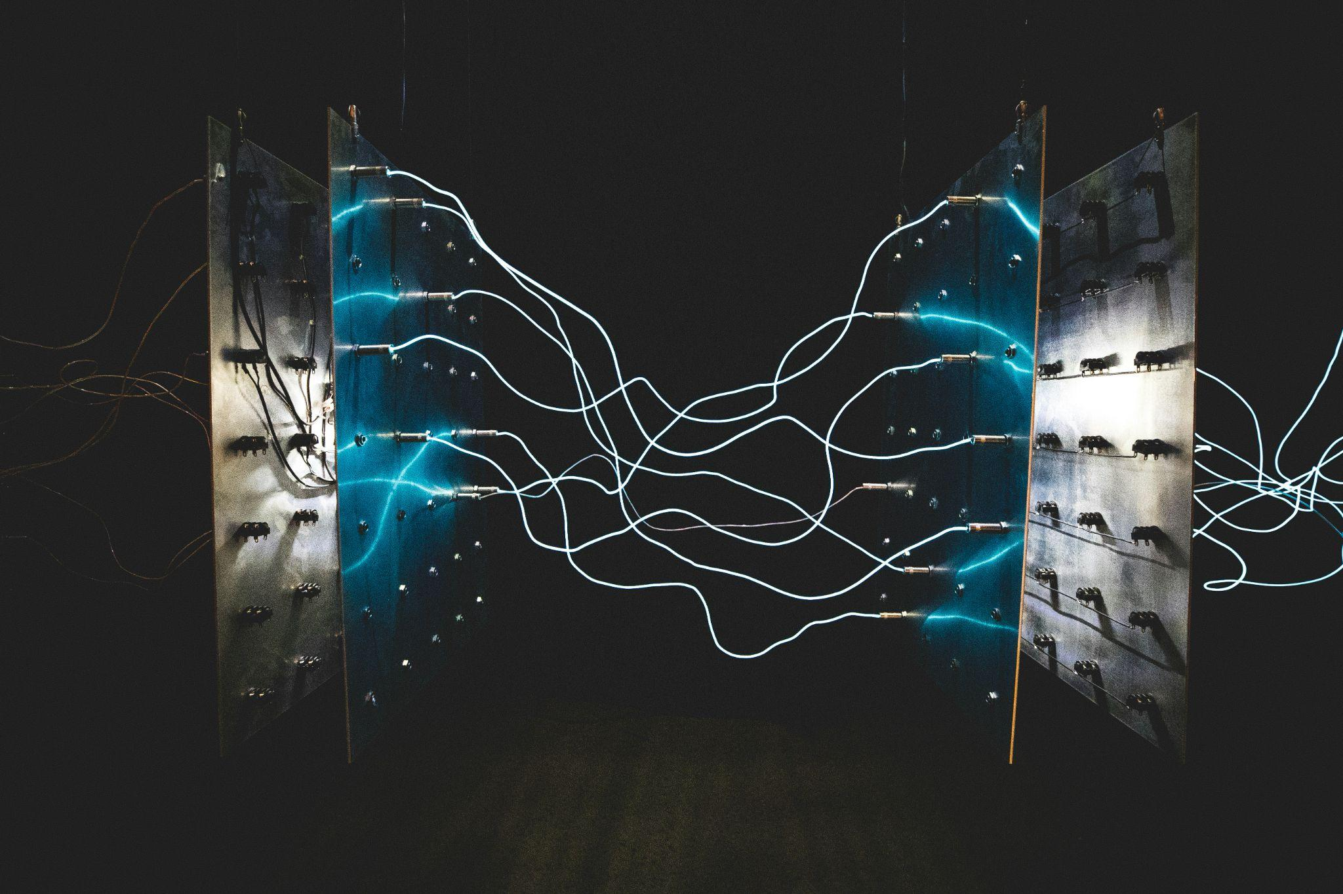

**Synopsis**: Today’s world is driven by circuitry, electronics and computing. Electromagnetic processes power the backbone of our modern society, from appliances that enable us to live comfortably, to life saving devices that extend lifespans, and the data servers upon which the internet relies. But what physical processes underlie the phenomena of electricity, and its close relationship with magnetism? How can we harness these processes to create the useful devices we are familiar with?

In this 1h50m course, we will dive into the fundamentals of electricity and magnetism, exploring electrostatics, circuits, and magnetic induction. We will then discuss applications to sound, particularly speaker building, and engage in a paper-plate speaker construction project for the last half of the class.

**Agenda**

**Part I: Force, Electrostatics, and Circuits** (30 minutes)

1. Introductions & Icebreakers
2. Force, Motion, and Fields
3. Charge & Coulomb's Law
   1. PhET Demo
4. Energy, Potential, and Voltage
   1. Activity: Whiteboard
5. (Briefly) Circuits

**Part II: Magnetism and Faraday’s Law** (20 minutes)

1. Magnetism & Magnetic Fields
   1. Activity: Compass & Bar Magnets
2. Flux (use a water flowing through a grating analogy)
   1. Demo
3. Faraday’s Law, Induction, and Applications
   1. Demo: Eddy Currents Video

**Part III: Sound** (10 minutes)

1. Mechanical Waves
2. Vibrations & Sound Waves
   1. Activity: Human Wave
3. Connecting with Inductance

**Part IV: Speaker Construction** (40 minutes)

1. Brief Recap
2. Build & Test speaker